2025 BOWMAN'S IBEST BASEBALL
FGC006531 8L12 CT.
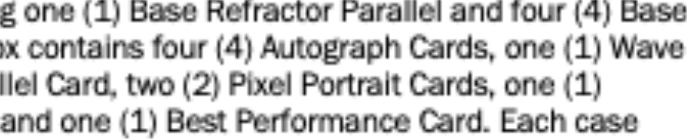
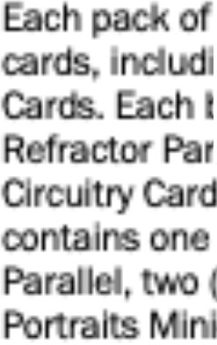
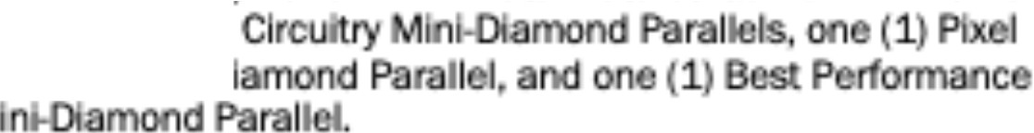
仄躙ゴロ血
2025Bowman♦sBest細畑I containsflvo (5) total n
)C
a
(1) 2025 MLBAII-S臼r Fultlre.sGama M1nば畑mood
怠
M

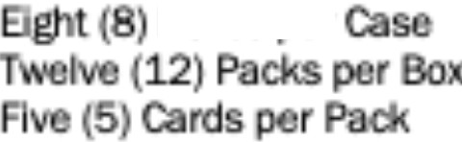
｀町℃暉O Pac1c:
Bmasoor

9DI-
゜

W叫m




GRJcery Pallall虹“伽： UPC BAR CODE&
|
II
111
||
|
ー

: 101/16 x 9 x 5 5/8 Inc,-
: 411/16 X 81/4 X 111\Ch

: 0.29 cubic ox:O、0224 ooblc f1

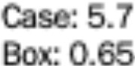
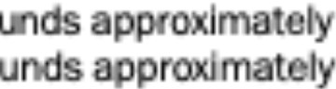
“)
po

16oas匂la匹r)(91叩心h圏‘=144

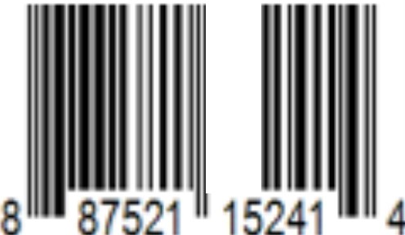
|||

Pack Box
52
12
5
78
5-
邸

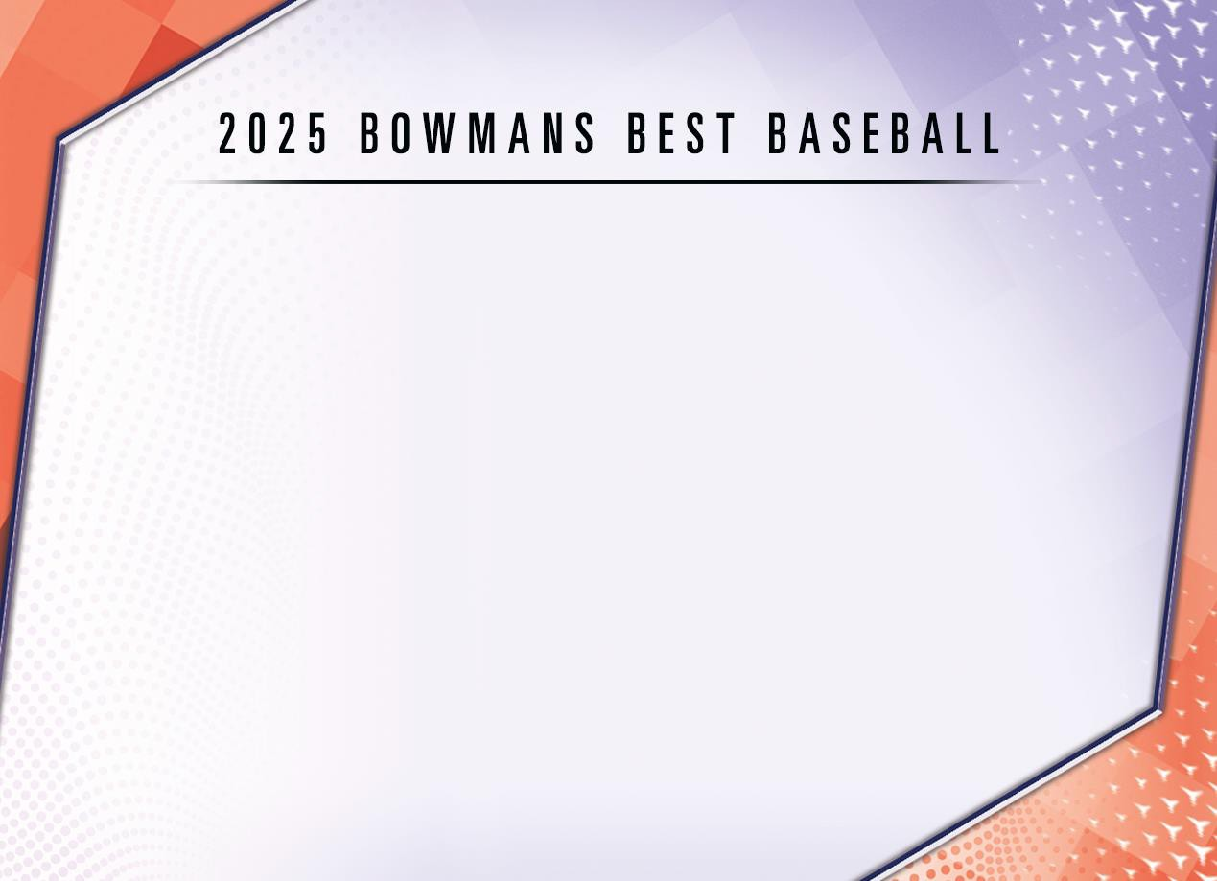

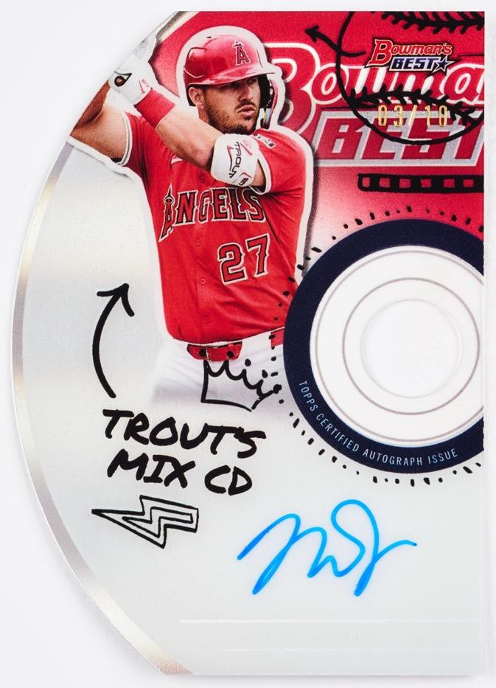
Best Mix Autographs

Only the best make the cut in this year’s Bowman’s Best release, spotlighting the game’s top performers.

Collect the entire 100-card Base Set featuring the BEST superstar, rookies, and prospects from around baseball.

Find 4 Chrome Autograph cards per Hobby Box!

Available in hobby shops January 2026!

Base Card

BASE CARDS


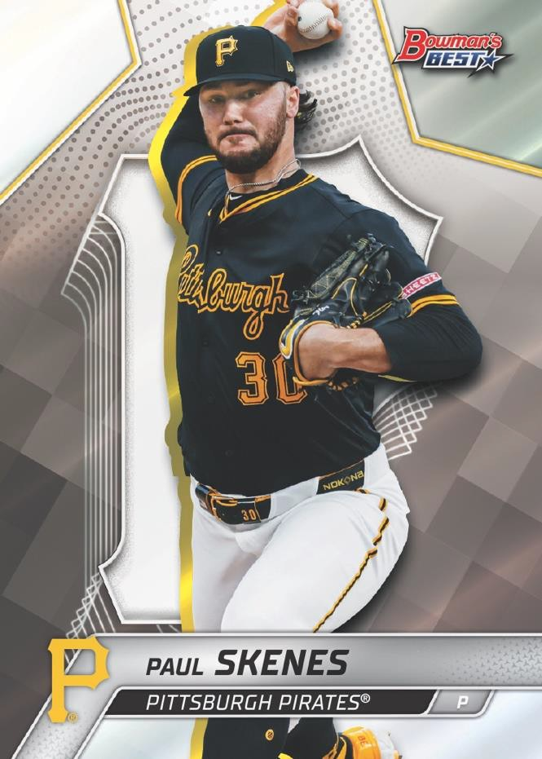
Base Card Parallels:
- Refractor Parallel
- Wave Refractor Parallel
- Lazer Refractor Parallel - #’d to 350 NEW!
- Mini-Diamond Refractor Parallel - #’d to 299
- Purple Refractor Parallel - #’d to 250
- Purple Mojo Parallel - #’d to 250
- Purple Lazer Parallel - #’d to 250 NEW!
- Aqua Lava Refractor Parallel - #’d to 199
- Aqua Refractor Parallel - #’d to 199 NEW!
- Blue Refractor Parallel - #’d to 150
- Blue X-Fractor Parallel - #’d to 150
- Blue Lazer Parallel - #’d to 150 NEW!
- Green Refractor Parallel - #’d to 99
- Green Mini-Diamond Refractor Parallel - #’d to 99
- Yellow Lazer Refractor Parallel - #’d to 75
- Yellow Refractor Parallel - #’d to 75 NEW!
- Gold Lava Refractor Parallel - #’d to 50
- Gold Refractor Parallel - #’d to 50
- Orange Refractor Parallel - #’d to 25
- Black Refractor Parallel - #’d to 10
- Red Refractor Parallel - #’d to 5
- Red Lava Refractor Parallel - #’d to 5
- SuperFractor Parallel - #’d 1-of-1

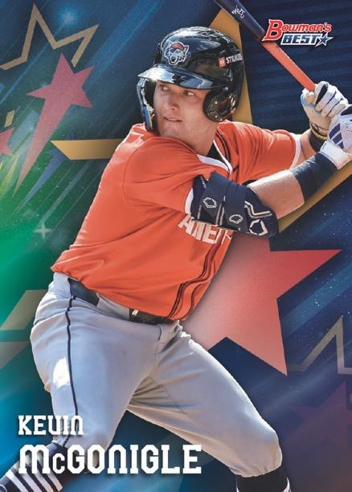

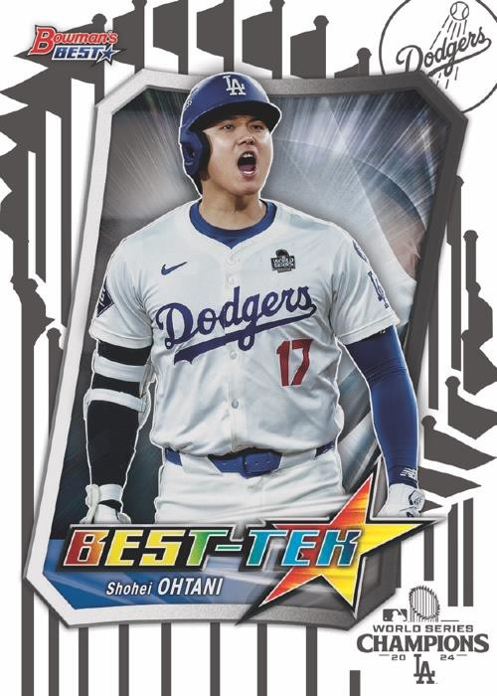
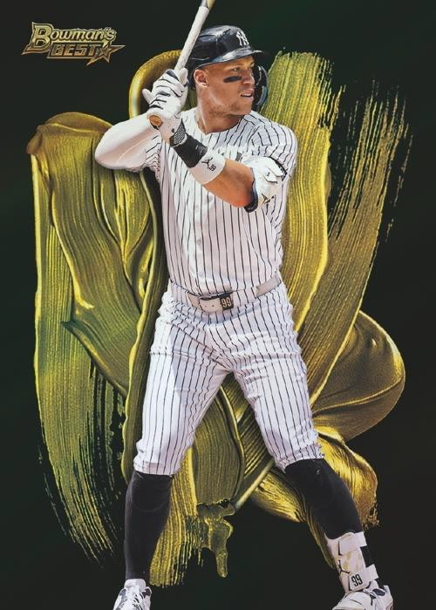
2025 MLB All-Star Futures Game
Best-Tek – Blue Parallel

INSERT CARDS
Look for an assortment of all-new variation themes and collectible insert sets!

2025 MLB All-Star Futures Game
  - Lava Refractor Parallel - #’d to 50
  - SuperFractor Parallel - #’d 1-of-1

Strokes of Gold
Pixel Portraits – NEW!
Circuitry – NEW!
Best Performance - NEW!

Bowman Showpieces
  - Mini-Diamond Refractor Parallel – Limited
  - Lava Refractor Parallel - #’d to 50
  - SuperFractor Parallel - #’d 1-of-1
Best-Tek – (#’d to 99) NEW!
  - Blue Parallel - #’d to 75
  - Gold Parallel - #’d to 50
  - Orange Parallel - #’d to 25
  - Red Parallel - #’d to 5
  - Black Parallel - #’d 1 of 1

Strokes of Gold

AUTOGRAPH CARDS


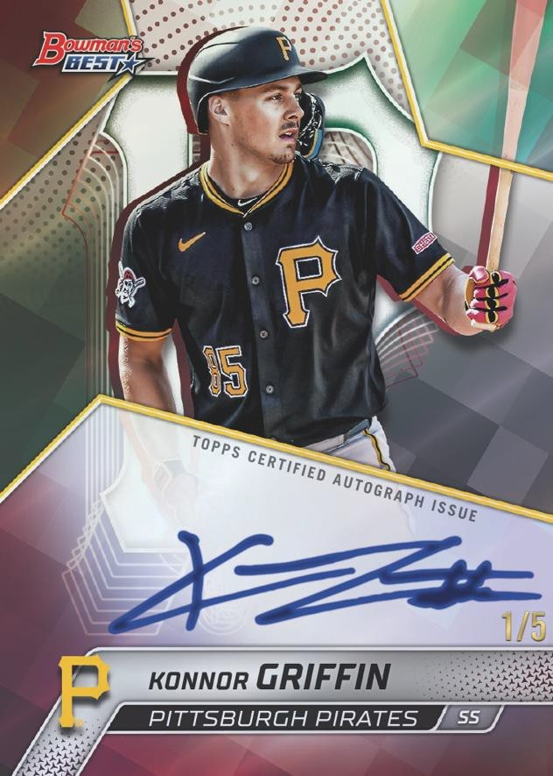
Best of 2025 Autographs
- Refractor Parallel
- Blue Refractor Parallel - #’d to 150
- Green Refractor Parallel - #’d to 99
- Purple Refractor Parallel - #’d to 75 NEW!
- Gold Mini-Diamond Refractor Parallel - #’d to 50
- Gold Refractor Parallel - #’d to 50
- Orange X-Fractor Parallel - #’d to 25
- Orange Refractor Parallel - #’d to 25
- Teal Refractor Parallel - #’d to 15
- Black Refractor Parallel - #’d to 10
- Black X-Fractor Parallel - #’d to 10 NEW!
- Red Refractor Parallel - #’d to 5
- Red X-Fractor Parallel - #’d to 5 NEW!
- SuperFractor Parallel - #’d 1-of-1
- Printing Plates - #’d 1-fo-1

Dual Autographs – #’d to 75
- Gold Refractor Parallel - #’d to 50
- Orange Refractor Parallel - #’d to 25
- Red Refractor Parallel - #’d to 5
- SuperFractor Parallel - #’d 1-of-1

Triple Autographs – #’d to 75

Best of 2025 Autographs –
Red Refractor Parallel
- Gold Refractor Parallel - #’d to 50
- Orange Refractor Parallel - #’d to 25
- Red Refractor Parallel - #’d to 5
- SuperFractor Parallel - #’d 1-of-1

AUTOGRAPH CARDS (cont.)
Quad Autographs – #’d to 75

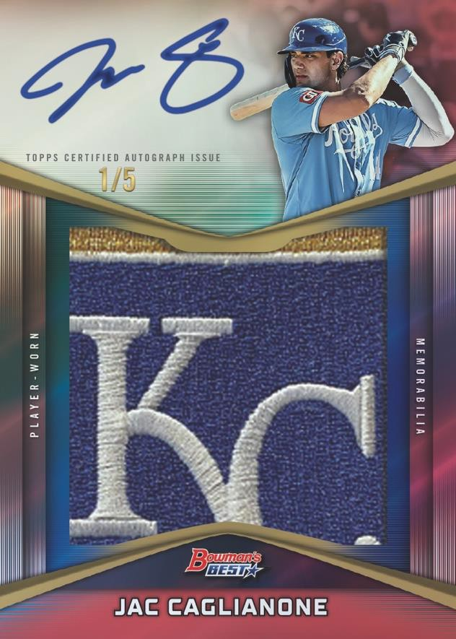
  - Lava Refractor Parallel - #’d to 50
  - Mini-Diamond Refractor Parallel - #’d to 25
  - SuperFractor Parallel - #’d 1-of-1
Family Tree Dual Autographs – Varied #ing
Family Tree Triple Autographs – Varied #ing
  - Mini-Diamond Refractor Parallel - #’d to 10
  - SuperFractor Parallel - #’d 1-of-1
Best Mix Autographs – #’d to 10 NEW!
Best Performance Autographs – Varied #ing NEW!
  - Lava Refractor Parallel - #’d to 50
  - Mini-Diamond Refractor Parallel - #’d to 25
  - SuperFractor Parallel - #’d 1-of-1
Best-Tek Autographs – Varied #ing NEW!
  - Gold Parallel - #’d to 50
  - Orange Parallel - #’d to 25
  - Red Parallel - #’d to 5
  - Black Parallel - #’d 1 of 1
Circuitry Autographs – #’d to 99 NEW!
Bowman Showpieces Autographs – #’d to 99
  - SuperFractor Parallel - #’d 1-of-1

Prospect Patch Autograph –
Red Refractor Parallel
Prospect Patch Autograph – #’d to 50 NEW!
- Orange Refractor Parallel - #’d to 25
- Black Refractor Parallel - #’d to 10
- Red Refractor Parallel - #’d to 5
- SuperFractor Parallel - #’d 1-of-1

